

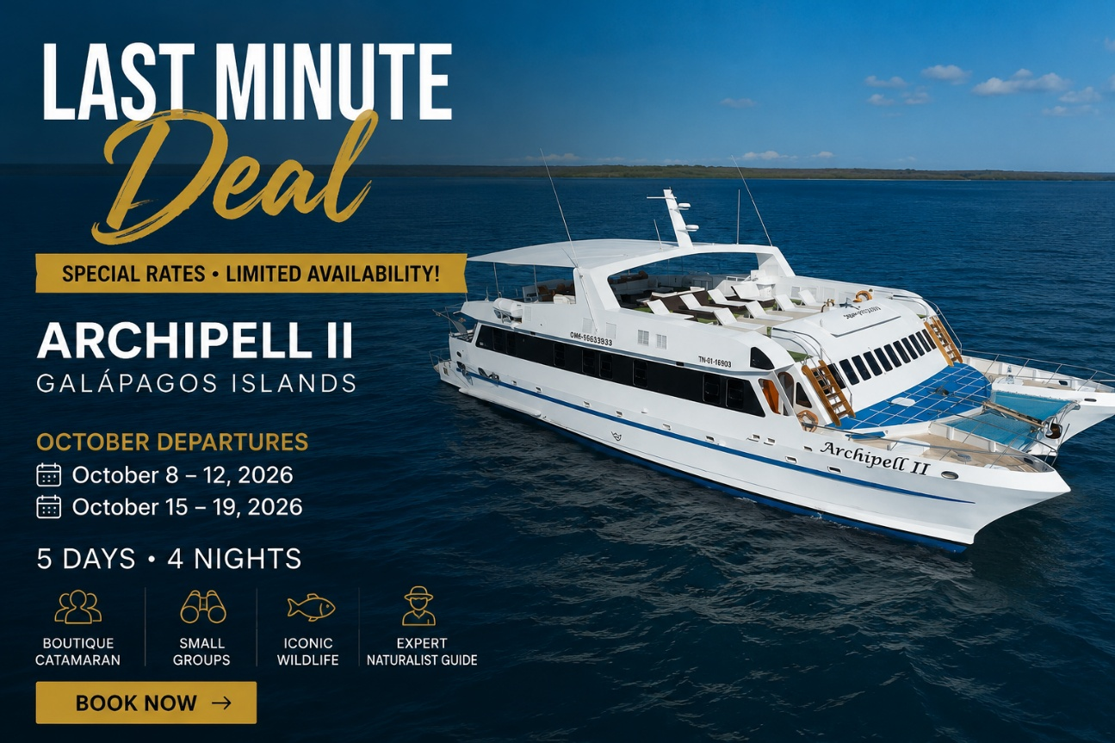

Discover the islands in comfort and style.
Our dedicated team ensures every guest enjoys a seamless and unforgettableexperience.
We’re here to support you with availability, itineraries, and partner rates.
Let’s keep sharing the magic of Ecuador and the Galápagos Islands together.

EMAIL: braga.bonnie@gmail.com for booking and info

