10 DAY AFRICAN SAFARI – ARUSHA, KARATU, NORTHERN SERENGETI, SERONERA, KARATU
Introduction
- This 10-day safari will take your breath away, filling you with lifetime memories of Tanzania’s outstanding wildlife encounters in its most extraordinary locations. Every hour of every day, a new adventure awaits.
- Your driver-guide will take you safely on this journey full of adventure. No one knows the wildlife routines better; no one can give you a deeper insight into our country’s culture. Extraordinary experiences await adventurous travelers with open minds.
- Visit the ‘endless plains’ of Serengeti, a stunning landscape, and surely the
The world’s most celebrated national park with an incomparable range of predators and their intended prey: see leopard and cheetah, antelope, Wildebeest, and zebra.
- Ngorongoro Crater is a collapsed volcano some 12 miles across, with its incredible year-round display of wildlife. A truly inspiring setting that plays host to lion and elephant, rhino, buffalo, and hippo as well as many other species and endless birdlife.
- Flamingo.
- Optional Activities:
- Balloon Safari in Serengeti: USD 750 per person
- Olduvai Gorge USD 60
Information 4 Guests 10 Days / 9 Nights
Accommodation Summary
Start  /  Check in | Check out | Stay | Basis
Day 1 | Day 3 | 2 Nights | FB
Day 3 | Day 4 | 1 Night | FB
Day 4 | Day 6 | 2 Nights | FB
Day 6 | Day 8 | 2 Nights | AI
Day 8 | Day 10 | 2 Nights | FB
FB: Full Board - Dinner, Bed, Breakfast and Lunch
AI: All Inclusive - Bed and All Meals
Transfer 65.71 km - 1 hour 20 minutes
A
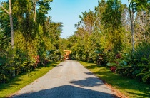
Under The Shade Safari Lodge
Lodge • 2 Nights
Under The Shade Safari Lodge
Scheduled Flight
B
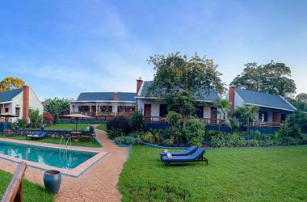
Martina’s Retreat
Lodge • 1 Night
Transfer
287.47 km
5 hours 42 minutes
C
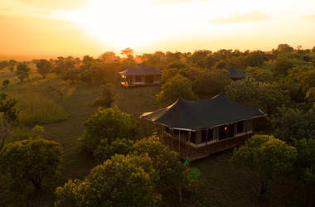
Moyo Migration Camp Mara
Camp • 2 Nights
Transfer
133.81 km
2 hours 51 minutes
D
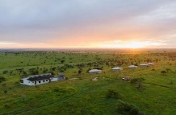
Salinero Serengeti Lodge
Lodge • 2 Nights
Transfer
136.60 km
2 hours 38 minutes
E
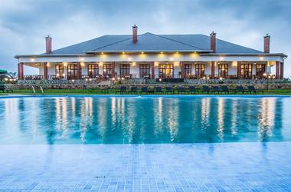
Ngorongoro Coffee Lodge
Lodge • 2 Nights
Transfer
231.56 km
4 hours 13 minutes
Close
Recentre
Transport Summary
Flights
Date | Flight | Departure | Arrival
Day 3 | Scheduled flight | Under The Shade Safari Lodge | Martina’s Retreat
Transfers
Date | Type | Pick Up | Drop Off
Day 1 | Transfer | Kilimanjaro International Airport [JRO] | Under The Shade Safari Lodge
Day 4 | Transfer | Martina’s Retreat | Moyo Migration Camp Mara
Day 6 | Transfer | Moyo Migration Camp Mara | Salinero Serengeti Lodge
Day 8 | Transfer | Salinero Serengeti Lodge | Ngorongoro Coffee Lodge
Day 10 | Transfer | Ngorongoro Coffee Lodge | Kilimanjaro International Airport [JRO]
Pricing
NET PRICE PER PERSON SHARING.
2pax= $5,755
3pax= $5,110
4pax= $4,790
5pax= $4,595
6pax=$4,470

Includes

- All lodge, camp, and hotel accommodations are listed based on double room sharing.
- House drinks at Maramara Tented Lodge and Oleserai Tented Camp
- Transport with our Toyota Land Cruiser 4x4 with a pop-up roof for game drive, fitted with HF radio communication.
- Dedicated Services of African Travel tour English/Spanish speaking guide (possibility for more languages upon request in advance)
- All park fees, Transit fees, and Crater fees
- Government VAT fees
- Flying balloon
- Meals as prescribed in the itinerary
- Enough water
- Local flight from Kogatende to Zanzibar via Arusha.
- Balloon Safari fly in Serengeti
- Animal feeding at Serval wildlife

Excludes
Excluded from the Safari Price
- International flight
- Visa fees
- Tips and gratuities to the crew/personnel
- Items of a personal nature – spa treatments, laundry, mini-bars, cigarettes
- Zanzibar tourist fees $40 tobe paid at airport
- Infrastarcture of $5each day per person to be collected by the hotel.

Destination
Arusha
Day 1 - 3
Resting at the foot of Mount Meru, the sprawling city of Arusha is known as the safari capital of northern Tanzania. It serves as an excellent base from which to explore the remarkably scenic surrounding area which includes majestic Mount Kilimanjaro, as well as the Manyara, Tarangire and Ngorongoro National Parks. Arusha is a good spot to take a day or two off from the safari circuit as it features a temperate climate and lush surrounds. Visitors can look forward to exploring the wildlife-abundant Serengeti National Park; the magnificent Arusha National Park; and taking on the challenge of climbing Mount Meru, Africa’s fifth highest mountain.
- Gallery
- Map
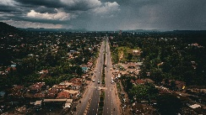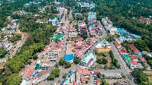
Credit: Shutterstock/ MOIZ HUSEIN STORYTELLER
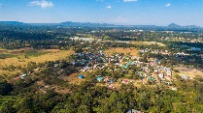
Credit: Shutterstock/ MOIZ HUSEIN STORYTELLER
Accommodation
Under The Shade Safari Lodge
Arusha
•
Day 1 - 3
Your Stay
Nights: 2
Basis: Full Board - Dinner, Bed, Breakfast and Lunch
Drinks: Tea, Coffee and Soft Drinks Included
- Gallery
- Information
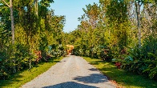
Credit: UnderTheShadeSafariLodgehttps://www.undertheshadesafarilodge.co.tz/
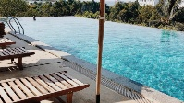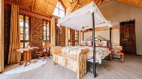
SafariLodgehttps://www.undertheshadesafarilodge.co.tz/
Experiences
Day 1 Under The Shade Safari Lodge • Arusha
Day Notes
MEETING AND GREETINGS.
Your driver guide will meet you at airport, transfer to Arusha where you will meet your safai planner for intered program overview. Transfer from Kilimanjaro International Airport [JRO] to Under The Shade Safari Lodge Check-in to Under The Shade Safari Lodge
Day 2
Day Notes
MATERUNI WATERFALLS AND COFFEE TOUR
Start your mini-adventure with the short but fascinating drive from Moshi town up the lush slopes of Mount Kilimanjaro to the village of Materuni, approximately 1,800 m above sea level. This is market garden territory and has the perfect mixture of climate and soil to produce some of the BEST COFFEE IN AFRICA. You'll visit a coffee farm and learn about how coffee is grown, harvested, and processed, and you'll try your hand at roasting and preparing a fresh cup of coffee the Chagga way.
After a delightful coffee break (so much better than the ones at work!) you'll take a beautiful 45-minute HIKE through the hills and valleys en route to the Materuni Falls. You'll pass THROUGH BANANA AND COFFEE PLANTATIONS, up and down mini-valleys, across ridges, and through narrow, splashing rivulets. Along the way your guide will teach you about local plants and how they are used for food and traditional medicine, as well as giving you more insight into the local Chagga culture. It's your chance to ask questions about a lifestyle that's probably very different from your own! You'll hear the Falls before you see them, and once they come into view, you might be lucky enough to see a rainbow sheen as the splashing waters split the sunlight. The Falls are hidden away in a pristine valley with cliffs towering to 200ft overhead. The mountain waters fall straight down in a shimmering curtain to splash in the rippling pool where you can float, take a swim, and chill out -literally, as these are PURE MOUNTAIN WATERS and not yet heated by the sun. But it'll be welcome after your hike. Afterward, you will drive back to Moshi town for dinner and overnight at
Destination Karatu
Day 3 - 4
Travellers heading for the Serengeti and Ngorongoro Crater will pass through the town of Karatu in the green hills of Tanzania’s northern highlands. Presided over by the towering Ol Deani Volcano, this small, colourful town serves as a popular overnight stop for visitors exploring the area’s many game parks. The town offers a variety of activities including browsing the bustling marketplace, sampling beer at a local brewery, visiting a traditional homestead, or taking a guided walk through the Ngorongoro Forest in search of waterfalls and caves. Whether you are looking for cultural tours, hiking and biking opportunities, a chance to enjoy an authentic rural Tanzania experience, or simply a break between safari game drives, this underrated town has plenty to offer.

Credit: Shutterstock/ danm12

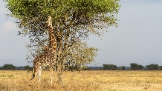
Credit: iStock/ AndreAnita
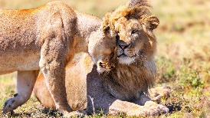
Credit: Shutterstock/ Maggy Meyer
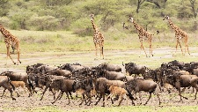
Credit: iStock/ Scott Canning
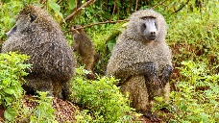
Credit: Shutterstock/ Roger de la Harpe
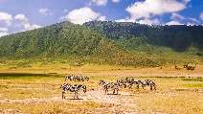
Credit: Shutterstock/ fokke baarssen
Accommodation Martina’s Retreat
Karatu
•
Day 3 - 4
Your Stay
Night: 1
Basis: Full Board - Dinner, Bed, Breakfast and Lunch
Drinks: Tea, Coffee and Soft Drinks Included
- Gallery
- Information
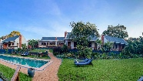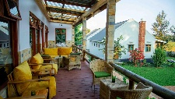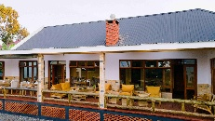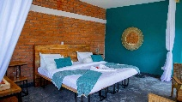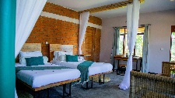
Credit: Martina'sRetreathttps://martinas.co.tz
Experiences
Day 3
Martina’s Retreat • Karatu
Day Notes
ARUSHA -TARANGIRE
After a leisurely breakfast, you will continue on a transfer to Tarangire National Park. One of the great parks with a variety of wildlife, it is considered one of the most beautiful wilderness areas in northern Tanzania. Tarangire Park hosts one of the largest elephant populations in Tanzania and is dotted with baobab and acacia thorn trees, adding more quality to the game drive. Besides the above details, the park is also home to various big cats, including lions, leopards, cheetahs, and tree-climbing pythons. Other wildlife inhabiting the game park includes many giraffes, buffalo, zebras, and various antelope species such as gazelles.
unch is to be held at the picnic site overlooking the Tarangire River. In the afternoon, drive to Manyara Conservation Area Authority, arrive at your lodge for dinner, and overnight.
Included L
Check-out from Under The Shade Safari Lodge
Scheduled from Under The Shade Safari Lodge to Martina’s Retreat
Check-in to Martina’s Retreat
VILLAGE WALK
Activity • Planned
NATURE WALK
Activity • Planned
MASAI CULTURE LESSONS
Activity • Planned
TRIBAL DANCERS & DRUMS
Activity • Planned
STORY TELLING AROUND FIREPLACE
Activity • Planned
FITNESS ACTIVITIES
Activity • Planned
Destination
Northern Serengeti
Day 4 - 6
Located between the Central Serengeti and Kenya’s Masai Mara National Reserve to the north, the Northern Serengeti is a remote African wildlife wonderland. The vast, rolling savannah of the Northern Serengeti, is known as the hub of the great migration. The landscape is characterised by vast stretches of savannah interspersed with acacia trees and riverine woodlands. Wildlife can be seen along the banks of the Mara River and visitors can view the annual spectacle of the half a million migrating wildebeest. Commonly spotted wildlife include: a multitude of plains game such as buffalo, zebra, gazelles, impala, giraffe as well as lion and leopard. Visitors can look forward to bird watching, hot air ballooning, game safaris and guided bush walks.
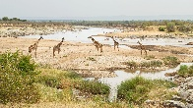
Credit: Shutterstock/ Cat Downie
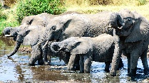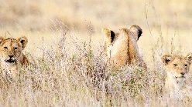
Credit: Shutterstock/ Andreas Spohr
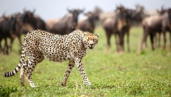
Credit: iStock/ Stanley Raymond
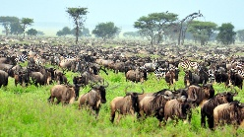
Credit: Shutterstock/ EastVillage Images
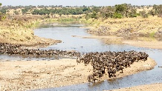
Credit: Shutterstock/ Peter van Dam
Accommodation
Moyo Migration Camp Mara
Northern Serengeti
•
Day 4 - 6
Your Stay
Nights: 2
Basis: Full Board - Dinner, Bed, Breakfast and Lunch
Drinks: Tea and Coffee Included
- Gallery
- Information
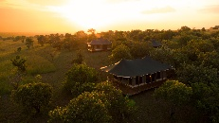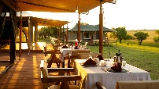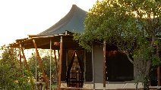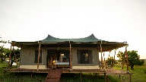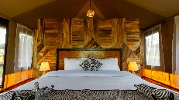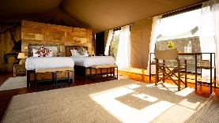
Credit: MoyoTentedCamphttps://moyotentedcamp.com/
Experiences
Day 4
Moyo Migration Camp Mara • Northern Serengeti
Day Notes
Karatu -Manyara
The Serengeti ecosystem is home to the "big five" (lion, African elephant, Cape buffalo, leopard, rhinoceros). The other main species include zebra, wildebeest, various species of gazelles and antelopes, giraffes, cheetahs, hyenas, elephants, hippopotami, crocodiles, and some primate species such as vervet monkeys and olive baboons. It is also an endemic bird area, with 505 species being documented so far. In the evening, we will arrive at the lodge for dinner and overnight.
Check-out from Martina’s Retreat
Transfer from Martina’s Retreat to Moyo Migration Camp Mara
Check-in to Moyo Migration Camp Mara
Adventures Aloft Balloon Safaris Serengeti
Activity • Planned
Adventures Aloft Balloon safaris flies over the spectacular Serengeti National park in Tanzania. They have a A415 balloon from Cameron Balloons, with a flying capacity of 16 and a 12 seater balloon, each and is able to fly 60 passengers a day. Flights take off at 6.30 each morning in time with the sunrise and allow one to experience an eagle’s view of the Serengeti and all it’s beauty. To complete the celebration a champagne breakfast is served on the Mara plains after the flight , complete with butler service and an open bar.
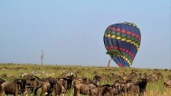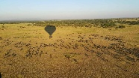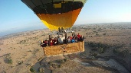
Day 5
Day Notes
Hot Air Balloon Safari – Northern Serengeti Migration Experience
Rise before dawn for a truly magical experience — a hot air balloon safari over the vast plains of the Northern Serengeti, one of the best places on Earth to witness the Great Migration from the sky.
As the sun begins to rise, you’ll lift gently off the ground, floating silently above the golden savannah. From this unique vantage point, watch the endless columns of wildebeest and zebras moving across the landscape, heading toward the Mara River in their timeless search for greener pastures.
The early morning light casts a warm glow over the plains, and the view from above reveals herds of animals spread across the horizon — elephants, giraffes, topis, and even predators like lions and hyenas beginning their morning hunt.
Your balloon pilot will guide you along the riverbanks and valleys where wildlife is most concentrated, offering unmatched photographic opportunities and a serene, breathtaking experience that few ever get to witness.
After landing, you’ll be treated to a champagne bush breakfast, served in the wild — a perfect end to an unforgettable morning adventure.
This is not just a balloon ride. It’s a moment of pure magic, where you become part of the Serengeti’s rhythm and witness the migration like never before — from the sky.
Destination
Seronera
Day 6 - 8
The Seronera region, in the central Serengeti, is set directly on the Great Migration route and offers excellent viewing of this incredible annual phenomenon, when countless wildebeest flood the area and move across the plains. While migratory game populations fluctuate seasonally, Seronera is still a wildlife hotspot at other times of the year, sheltering the Big Five, among many other species. A number of small campsites provide accommodation and visitors can enjoy hot air balloon trips and walking safaris as well as guided game drives.
 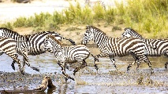 redit: Shutterstock/ Kjetil Kolbjornsrud
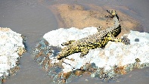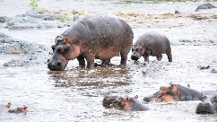
Credit: Shutterstock/ Oleg Znamenskiy
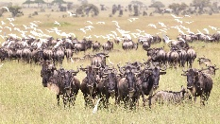
Credit: Shutterstock/ Matej Kastelic
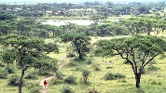
Credit: iStock/ FernandoQuevedo
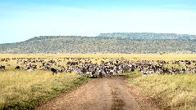
Credit: Shutterstock/ nwdph
Accommodation
Salinero Serengeti Lodge
Seronera
•
Day 6 - 8
Your Stay
Nights: 2
Basis: All Inclusive - Bed and All Meals
Drinks: All Local Brands (Spirits, Wine and Beers) Included
- Gallery
- Information
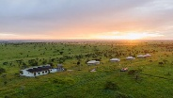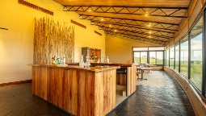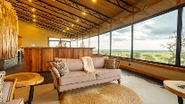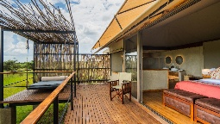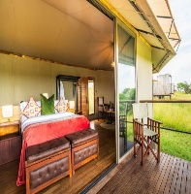
Credit: SalineroHotelshttps://salinerohotels.com/
Experiences
Day 6
Salinero Serengeti Lodge • Seronera
Day Notes
NORTH -CENTRAL SERENGETI
Bed, chorus, and smells of Africa are all around you, and ahead is a full day of adventure in the world’s most famous national park. Around 6:30 am, get ready for breakfast, around 7:30 am, check out for the morning game view en route to central serengeti, arrival for dinner and overnight.
Check-out from Moyo Migration Camp Mara
Transfer from Moyo Migration Camp Mara to Salinero Serengeti Lodge
Check-in to Salinero Serengeti Lodge
Day 7
Day Notes
Fully day Central Serengeti
Waking up in the Serengeti is something special. Sights, sounds, and smells of Africa are all around you, and ahead is a full day of adventure in the world’s most famous national park. Around 5:00 am, a walk-up call rings, you are mid-up, ready for a balloon safari and sunrise stunning rays reflecting your face and camera lenses around 6 am. This adventure takes 60 minutes in the air, slowly landing with a big smile covered by champagne’s sparkling bubbles from your balloon pilot. Breakfast served under African acacia’s shadow. After breakfast, we start today with the morning section of our game drive in Serengeti along the Mara River, searching for migration crossing the river
Destination
Karatu
Day 8 - 10
Travellers heading for the Serengeti and Ngorongoro Crater will pass through the town of Karatu in the green hills of Tanzania’s northern highlands. Presided over by the towering Ol Deani Volcano, this small, colourful town serves as a popular overnight stop for visitors exploring the area’s many game parks. The town offers a variety of activities including browsing the bustling marketplace, sampling beer at a local brewery, visiting a traditional homestead, or taking a guided walk through the Ngorongoro Forest in search of waterfalls and caves. Whether you are looking for cultural tours, hiking and biking opportunities, a chance to enjoy an authentic rural Tanzania experience, or simply a break between safari game drives, this underrated town has plenty to offer.

Credit: Shutterstock/ danm12
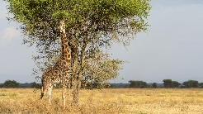
Credit: iStock/ AndreAnita
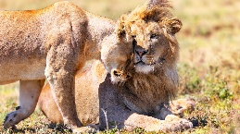
Credit: Shutterstock/ Maggy Meyer
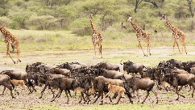
Credit: iStock/ Scott Canning
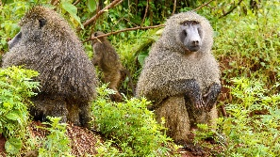
Credit: Shutterstock/ Roger de la Harpe
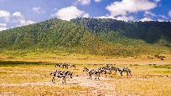
Credit: Shutterstock/ fokke baarssen
Accommodation
Ngorongoro Coffee Lodge
Karatu
•
Day 8 - 10
Your Stay
Nights: 2
Basis: Full Board - Dinner, Bed, Breakfast and Lunch
- Gallery
- Information
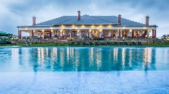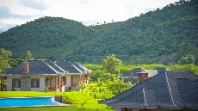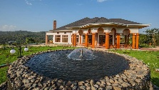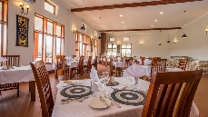
Credit: NgorongoroCoffeeLodgehttps://ngorongorocoffeelodge.com
Experiences
Day 8
Ngorongoro Coffee Lodge • Karatu
Day Notes
SERENGETI- CRATER- KARATU
Today, after your early morning game breakfast, drive to Ngorongoro Crater, arrive around 10 am, and start descending the crater. With its abundant water, excellent grazing, and natural protection from the densely vegetated crater walls, the crater provides shelter to over 25000 animals, including the endangered Black, which later ascend out to Karatu.
Check-out from Salinero Serengeti Lodge
Transfer from Salinero Serengeti Lodge to Ngorongoro Coffee Lodge
Check-in to Ngorongoro Coffee Lodge
Day 9
Day Notes
Relaxation Day at the Hotel After Safari
After your safari adventure, enjoy a full day of rest and relaxation at the hotel. This day is designed for you to unwind, recharge, and make the most of the hotel’s facilities.
Start your morning with a leisurely breakfast, followed by time at the swimming pool where you can relax on a sunbed, take a refreshing swim, and enjoy the peaceful atmosphere. During the day, you are free to explore and use the hotel’s amenities at your own pace—whether that means visiting the spa (if available) for a massage or treatment, spending time in the lounge areas, or simply reading a book in a quiet corner of the garden.
You may choose to have lunch at the hotel restaurant, sampling local and international dishes, and then continue your afternoon with more pool time, a walk around the property, or other available activities such as the gym or wellness facilities.
In the evening, relax with a drink at the bar or by the pool, followed by a comfortable dinner at the hotel. This is a completely flexible, easy-going day focused on rest, comfort, and enjoying the hotel environment before continuing with the next part of your journey.
Day 10
Day Notes
Last Day in Zanzibar – Farewell to Paradise
Experience the Vibrant Culture and Nature of Mto wa Mbu
MTO WA MBU - KILIMANJARO AIRPORT.
Located at the foot of the Great Rift Valley escarpment, Mto wa Mbu is one of Tanzania’s most unique cultural melting pots — and a perfect stop for immersive, off-the-beaten-path experiences.
🌿 Cycling Safari to the Lake Manyara Buffer Zone
Hop on a bike and cycle through lush farmlands and open savannah towards the Lake Manyara buffer zone. Along the way, enjoy stunning scenery and spot wildlife like zebras, giraffes, wildebeest, and various bird species roaming freely near the edge of the park — all while accompanied by a local guide who knows the area best.
🍌 Banana & Rice Farms Tour
Discover the heart of the village’s livelihood by visiting local banana and rice plantations. Learn how different banana varieties are used for food and brewing, and observe traditional rice farming methods passed down through generations.
🎨 Local Crafts & Brewing Experience
Visit skilled wood carvers (Makonde artists) who create beautiful African sculptures and masks, and wrap up your tour by joining locals for a taste of traditional banana beer — a fun and authentic community experience.
This is a journey full of color, culture, and connection — where you’ll see the real Tanzania, up close. Late after local lunch drive to kilimanjaro airport.
Check-out from Ngorongoro Coffee Lodge
Transfer from Ngorongoro Coffee Lodge to Kilimanjaro International Airport [JRO]
End of Itinerary
Terms and Conditions
Itinerary Terms and Conditions
Cancellation Policy
1. Cancellation made before 90days of arrival 25% will be charged
2. Cancellation made 60-45 days 50% will be charged
3. Cancellation made 45-30days 100 , % will be charged.
EMAIL: braga.bonnie@gmail.com for details.

